CECS 346 Lab 6 – Edge Triggered and SysTick Interrupts

Preparation: You will need a TI TM4C123 LaunchPad.
Book Reading: Textbook Sections 9.4, 9.5, 9.6
Starter Project: Lab6_Interrupts.
Example Projects: HelloLaunchPad, Edge_Interrupt, PeriodicSystickInts.

Project goal: To learn how to use Edge Triggered and SysTick Interrupts and learn how to use the Memory and Watch windows in Keil uVision simulator during on-board debugging.

System Description:

The embedded system will start with the onboard red LED on and blink at a speed of 0.5s on/0.5s off. Every time the onboard switch 2 (PF0) is pressed and released, the LED color will be changed to the next color in a round robin order of red, blue, and green. The new LED will blink at the same speed.

System Requirements:
- You will write code using “friendly” initialization to initialize 3 different functionalities such that all 3 functionalities will work regardless of the order the initialization functions are called. You will code keeping in mind the Embedded System Coding Standards.
- In this lab you will flash the onboard red/blue/green LEDs. Instead of using a software loop to generate 0.5s delay, you will use a SysTick interrupt approach to generate the same time delay. Set the priority for SysTick interrupt to be 1.
- You will create a rising edge triggered interrupt on PF0 to toggle through the three LEDs. Set the priority for this edge triggered interrupt to be 4.

Procedure:
- Download Lab6_Interrupts.zip. Note there are 4 functions that require being implemented:
  - Switch_LED_Init() - Initialize Port F LEDs and rising edge trigger interrupt for PF0 (SW2).
  - SysTick_Init() - Initialize SysTick timer for 0.5s delay with interrupt enabled.
  - GPIOPortF_Handler() - Handle GPIO Port F interrupts.
  - SysTick_Handler() - Handle SysTick interrupts.
- Implement Switch_LED_Init() to initialize the three onboard LEDs and rising edge triggered interrupt for PF0 (SW2) using friendly coding.
- Implement SysTick_Init() to initialize a SysTick timer with 0.5 sec delay (assuming the board is running at 16 MHz) that generates interrupts using friendly coding.
- Implement GPIOPortF_Handler() to do whatever is necessary toggle through the three LEDs in a round robin way.
- Implement SysTick_Handler() to flash the currently selected LED.
- Compile and simulate it.
- View the value of LED in the Watch 1 window. To open Watch 1 window while debugging, go to View menu -> Watch Windows -> Watch 1.
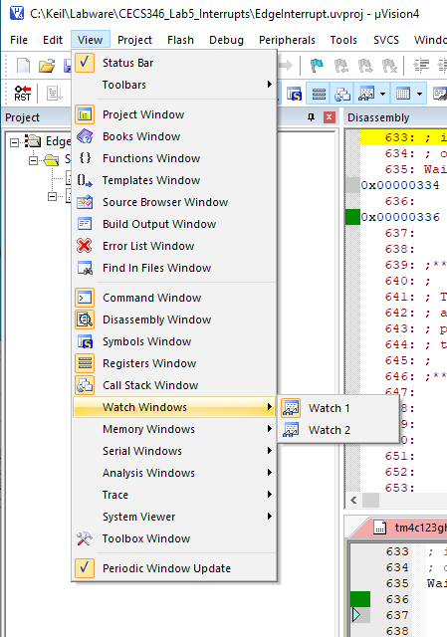
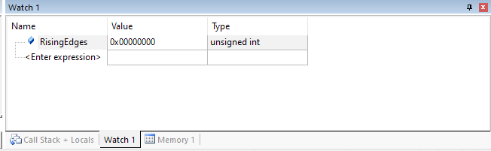
- Once Watch 1 is visible, we want to see the value of RisingEdges. Double click on the text “<Enter expression>” and type “RisingEdges”. The value of RisingEdges should be visible.

- View the value of RisingEdges in the Memory 1 window. To open the Memory 1 window while debugging, go to View menu -> Memory Windows -> Memory 1.
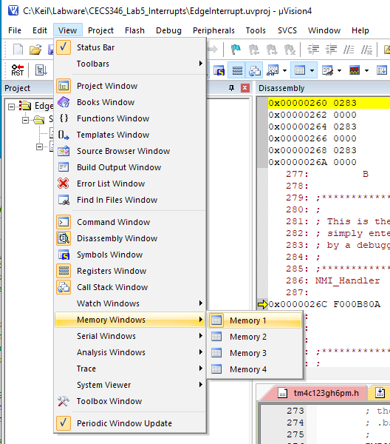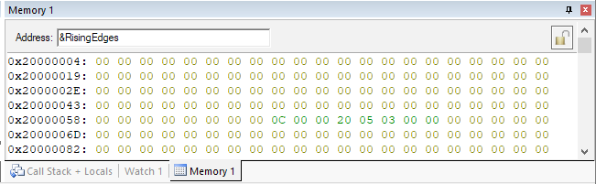
- Once Memory 1 is visible, type “&RisingEdges” in the Address box. The & represents we want to see the memory where RisingEdges is stored, not at the value of RisingEdges. (Think of &RisingEdges as the mailbox, and RisingEdges is what is in the mailbox.) Recall that the Cortex-M4 processor is little endian, so the first 4 bytes in the top left first row are the little endian value for RisingEdges.

Demonstration:
  - Simulate the project in Keil: Set grid to be 0.5s and show logic analyzer outputs for the three LEDs.
  - On board demo: Debug onboard, set break point in GPIOPortF_Handler(), open both memory and watch window to observe variable RisingEdges incrementing when PF0 (SW2) is released.

Deliverables:
Submit the following two files:
  - Software source code: CECS346Lab6.c.
  - Attach the following two items to the end of this lab description and submit it as a word or pdf file:
    - Memory window screenshot and watch window screenshot (could be same screenshot).
    - Screenshot for logic analyzer outputs for the three LEDs: make sure to include the blinking of all three LEDs.

